1. **Game Description**

Describe about the concept of the game and what is about ……. @ the given level

* + **Design Goal**

Describe in detail the aim of the game from the graphics and logic perspective

1. **Game Mechanics (Graphics Perspective)**
   * **Core game play**

Describe in detail how the player plays the game, what happens during the gaming

* + **Game flow diagram**

Draw the flow diagram of the game at every each steps and describe what is about

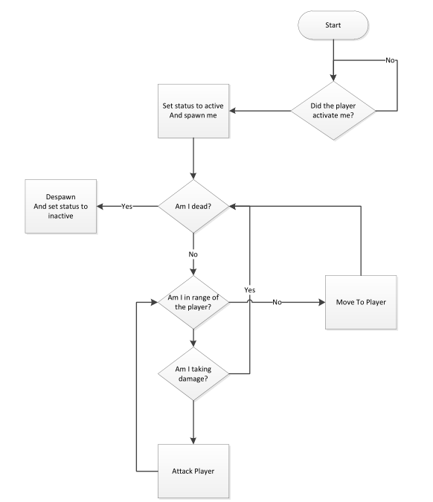

**START: ----------------------------------------------------------**

**Did the player Activate: -------------------------------------------**

**Set status Active: -------------------------------------------------------**

* + **Game physics and statistics**

Describe in detail the Physics and statistics of the gaming

Running: ---------------------

Jumping: -----------------------------

1. **Architectural Design** 
   * **Graphical Representation**

* Describing the given level using components and connectors. A simple example could be

Map

Environment

Player

Enemy

Weapons

Sound

* + **Description of Architecture Views**
* Every element in the Graphical representation must be clearly describes. For example
  + Environment: - what does the chosen environment look like?
  + Player
  + Enemies
  + **Interaction between views**
* How are each views interacting with each other.

1. **The high level and detail design**
   * Will be explained soon(You can read A Concise introduction to Software Engineering, Pankaj Jalote)